Report: Process Analysis of Finest Laundry
1. Title Page & Group Details
- Report Title: Operations Management: A Process Analysis of Finest Laundry
- Group Number: 10
- Group Members:
Rohit Ghosh MBA25084
Shashank Kurnal MBA25226
Anish Dey MBA25058
Abhishek Joshi MBA25051
Shreya Yadav MBA25090
Yoganshi MBA25096
Naman Srivastav MBATM25014
2. The Existing Process
- PROCESS START
- Purpose:
  - The process begins when a customer initiates the service — either by visiting the laundry outlet or scheduling a pickup. This marks the official start of garment processing at Finest Laundry.
- RECEIVE CLOTHES
- Purpose:
  - Once garments are received, they are logged into the system. Staff verify the quantity, type, and material of each item to ensure correct handling. Each item is inspected for visible stains, damages, or special cleaning instructions provided by the customer.
- SORTING AND TAGGING
- Purpose:
  - In this step, clothes are sorted based on fabric type, color, and cleaning requirements. For example, delicate fabrics like silk are separated from cottons or woollens. Each item is tagged with a unique identification label to ensure traceability and to avoid mix-ups throughout the process.
- Washing
- Purpose:
  - Sorted garments are moved to the machine washing unit, where they are cleaned using water, detergent, and fabric-appropriate washing cycles. This ensures removal of general dirt and light stains while maintaining fabric integrity.
- INSPECTION OF STAINS
- Purpose:
  - After washing, garments undergo quality inspection to check for stains or spots that remain. This step acts as a quality checkpoint:
    - If stains are found, the garments are directed to manual washing.
    - If no stains are found, they proceed directly to drying.
- IF STAINS FOUND:
  - MANUAL WASHING
  - Purpose:
    - Garments requiring additional treatment undergo manual washing or spot cleaning. Skilled staff use specialized cleaning agents to remove stubborn stains (like oil, ink, or wine) without damaging the fabric. After manual treatment, the clothes are sent to a smaller washing machine.
- IF STAINS NOT FOUND :
  - DRYING:
  - Purpose:
    - Clothes that pass inspection or have been manually cleaned are then sent for drying. The drying process is tailored to fabric type — machine drying for durable materials and air drying for delicate ones. This ensures that garments are completely dry and ready for pressing.
- PRESSING
- Purpose:
  - Once dry, garments are ironed or pressed to remove wrinkles and restore their crisp appearance. Depending on fabric and customer preference, this may involve:
    - Steam pressing for delicate garments.
    - Heat pressing for formal wear.
Pressing ensures a polished, ready-to-wear look.
- PACKING
- Purpose:
  - After pressing, the garments are folded or hung and packed using protective covers or eco-friendly packaging materials. Each package is labelled with the customer’s details to ensure accurate delivery.
- DISPATCH
- Purpose:
  - The packed garments are then dispatched — either handed over to walk-in customers or sent through a delivery service. The dispatch team verifies all items against the customer order before marking the process as complete.
- PROCESS STOP
- Purpose:
  - This marks the end of the laundry cycle. The process is closed in the system, and customer feedback may be collected to maintain service quality.
3. Task Analysis of Existing Process
- List of Tasks & Times:
  - Each lot is 30kg.
    - Task 1: Receive clothes from Customers
    - Task 2: Sorting and Tagging garments (Task Time: 10 mins/lot)
    - Task 3: Washing (Task Time: 42 mins/lot)
    - Task 4 : Inspection of Stains
      - Task 4a : If Stains found, Manual Washing (25 mins) then to smaller washing machine (10 mins) [Task Time : 35 mins /lot]
    - Task 5: Drying (Task Time: 25 mins)
    - Task 6: Pressing [2 stations ] (Task Time: 30 mins/lot)
    - Task 7: Packaging (Task Time: 60 mins/lot)

4. Existing Process Flow Diagram
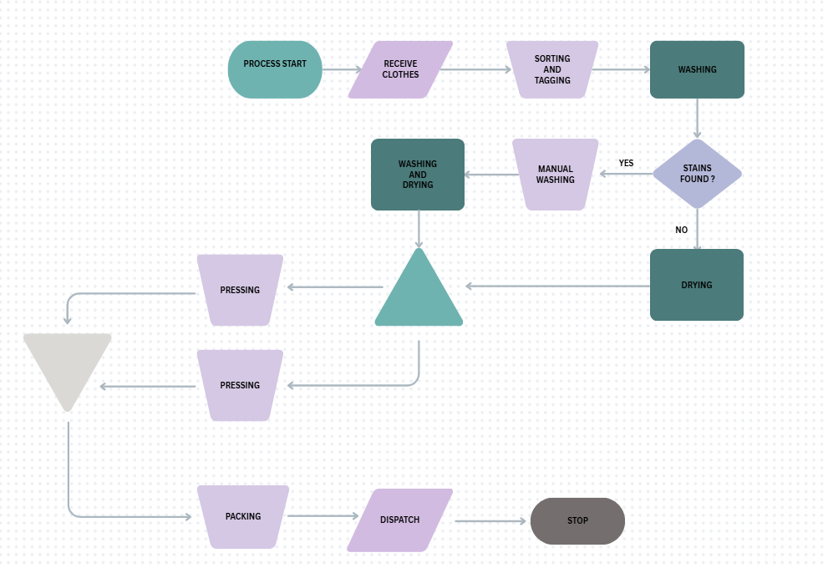

5. Analysis of Existing Process Metrics
Metric | Value
Throughput Time (No stains) | 167 mins
Throughput Time (Stains) | 202 mins
Cycle Time | 60 mins/lot
Bottleneck | Packaging
Capacity | 5 lots/day
Idle Time (No stains) | 133 mins
Idle Time (Stains) | 218 mins

6. Proposed New Process
- Proposal:
  - It is proposed to introduce parallel packaging capability by reallocating one employee from the Sorting & Tagging function to the Packaging function. This operational redesign will increase the packaging capacity from one operator (60 minutes per lot) to two operators working in parallel, effectively reducing packaging time to ~30 minutes per lot.
  - This labor reallocation is feasible as Sorting & Tagging requires only 10 minutes per lot, which allows the employee to be cross-utilized without disrupting upstream flow. No additional capital expenditure, machines, or external hiring is required.
- Justification:
  - a) Bottleneck Removal
    - Packaging currently represents the system bottleneck at 60 minutes per lot, constraining the process to ~5 lots/day.
By introducing parallel packaging, packaging time decreases to ~30 mins/lot, allowing the bottleneck to shift to the washing stage (42 mins/lot).
    - This aligns better with upstream and downstream processing times, improving line balance and flow continuity.
  - b) Capacity Improvement Without Capital Investment
    - This intervention leverages resource flexibility and cross-training, key lean and capacity management principles, generating a 43% increase in throughput without additional cost.
7. Comparative Analysis
- Efficiency & Effectiveness: Before vs. After
- Metric | - Existing Process | - Proposed Process | - Improvement / Impact
- Average Throughput Time (per lot) | - 169.5 mins | - ~3 hours (180 mins) | - ↓ Reduced by ~1.5 hours per order
- Cycle Time (per completed order) | - 60 mins | - 25 mins (balanced with pressing) | - ↓ Reduced by ~58%
- Bottleneck Task | - Packaging | - Pressing (25 mins/order) | - Shifted bottleneck → balanced workload
- Bottleneck Time | - 60 mins | - 25 mins | - ↓ Reduced by ~35 mins per order
- Daily Capacity | - 5 lots | - ~19 orders/day | - ↑ +137% increase in throughput
- Line Efficiency | - ~29% | - ~60% | - ↑ Improved by 31 percentage points
- Average Idle Time (per lot) | - 145.5 mins | - ~190 mins | - ↓ Reduced by ~45%

8. Appendix
- Photos/Pictures:
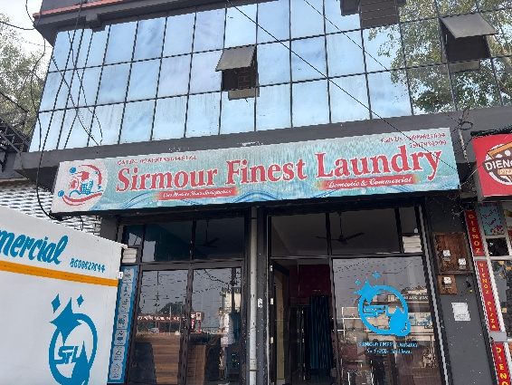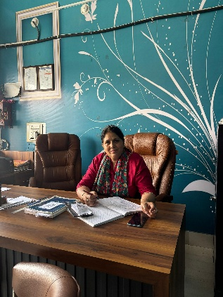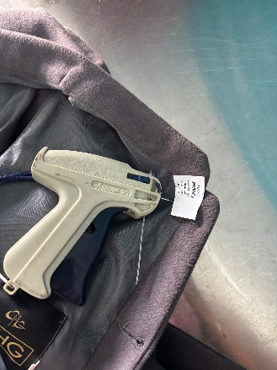
Store front Reception Tagging Clothes
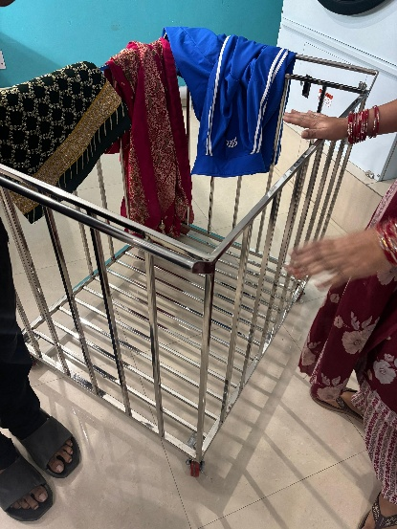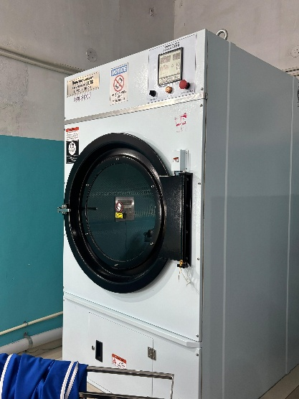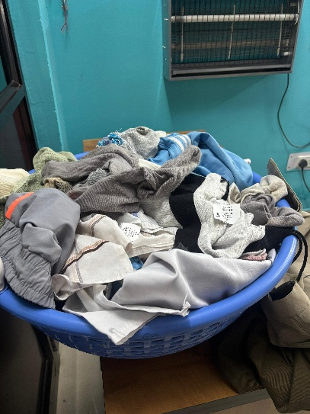
Trolley for moving lots Washing machine Unsorted clothes
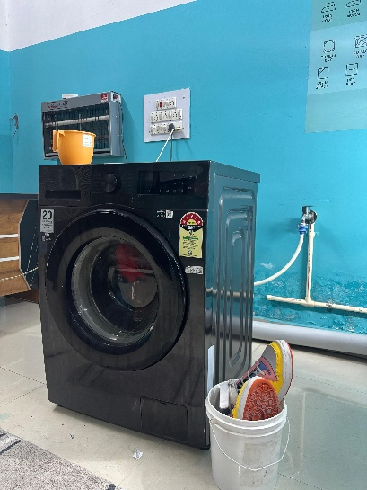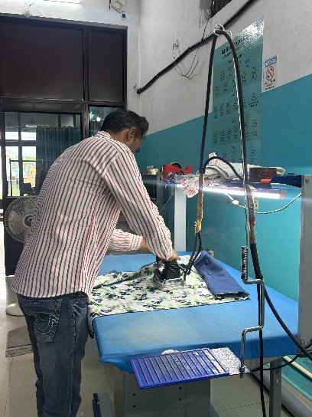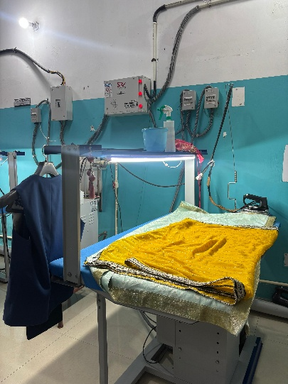
Manual washing unit Pressing bench in work Pressing bench idle
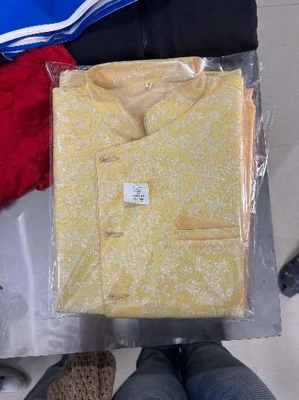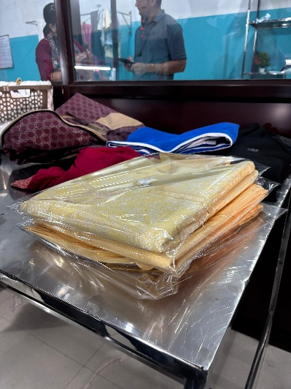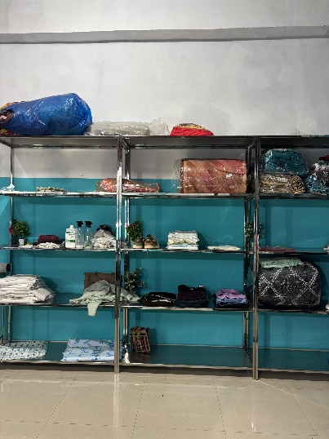
Packaged clothes Wrapped clothes Packed clothes ready to be dispatched
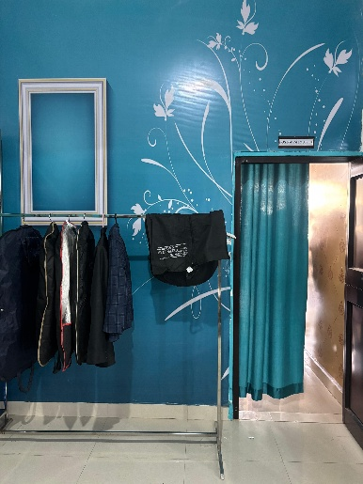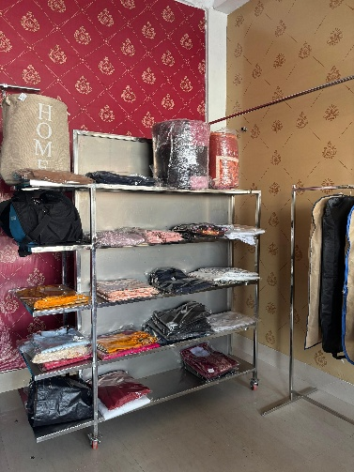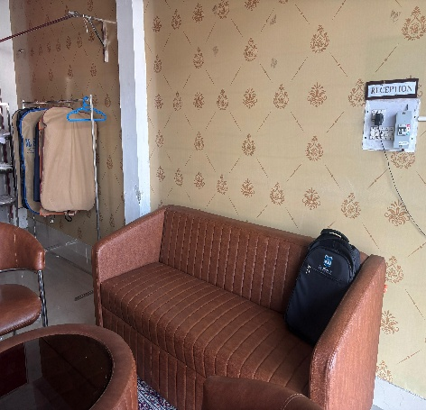
Dry cleaned clothes Ready to be dispatched Waiting room reception
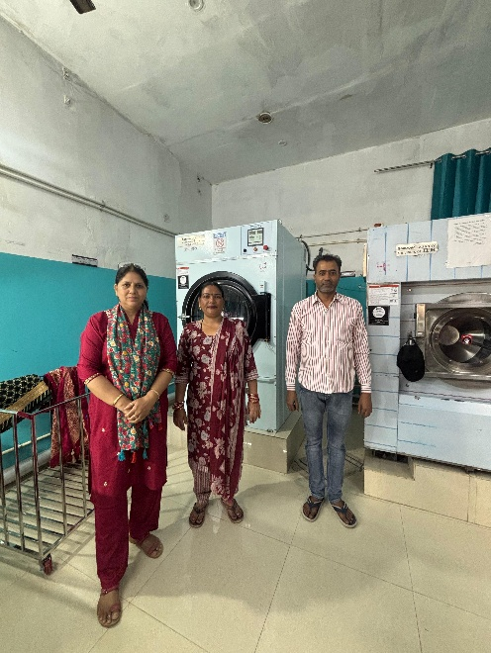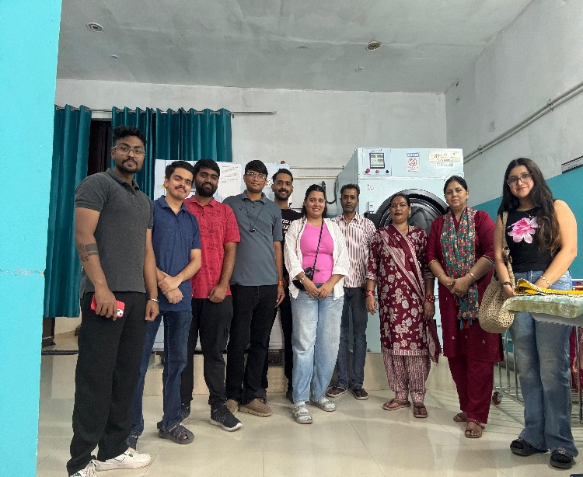
Finest Laundry working staff IIM Sirmaur Team

